Sprint - 1 Deliverables USN-1: Create IBM Cognos Analytics and IBM Cloud Account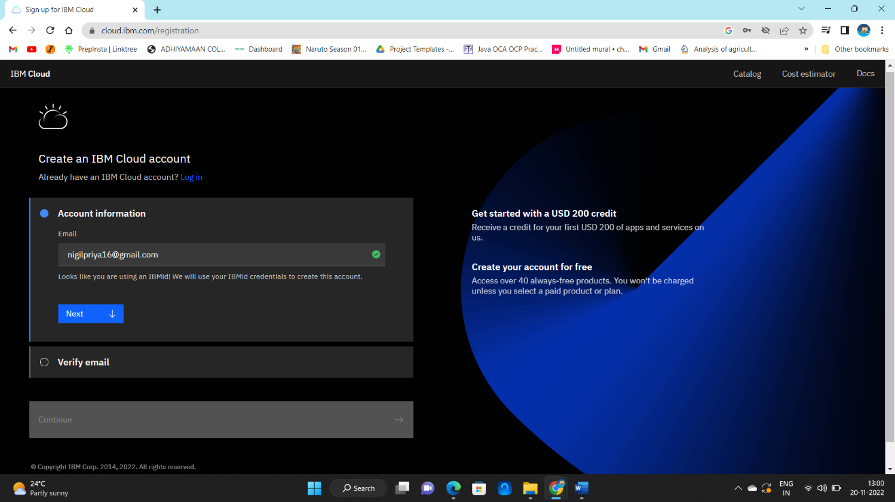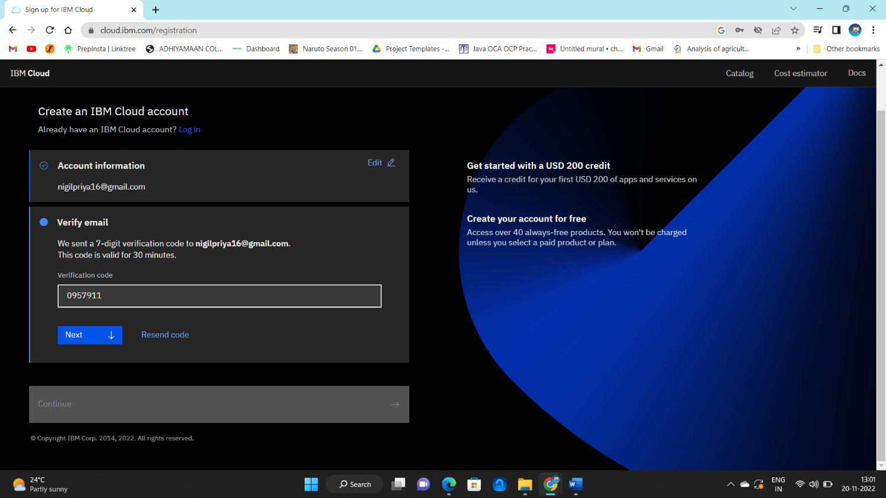

USN-2: Verifying account details and confirming the code in activation email

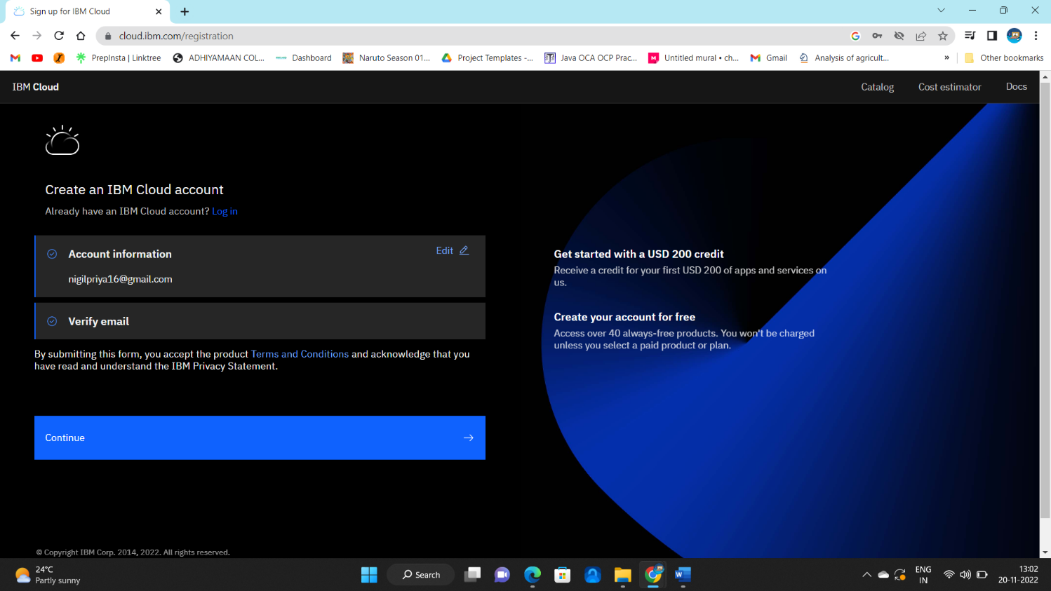

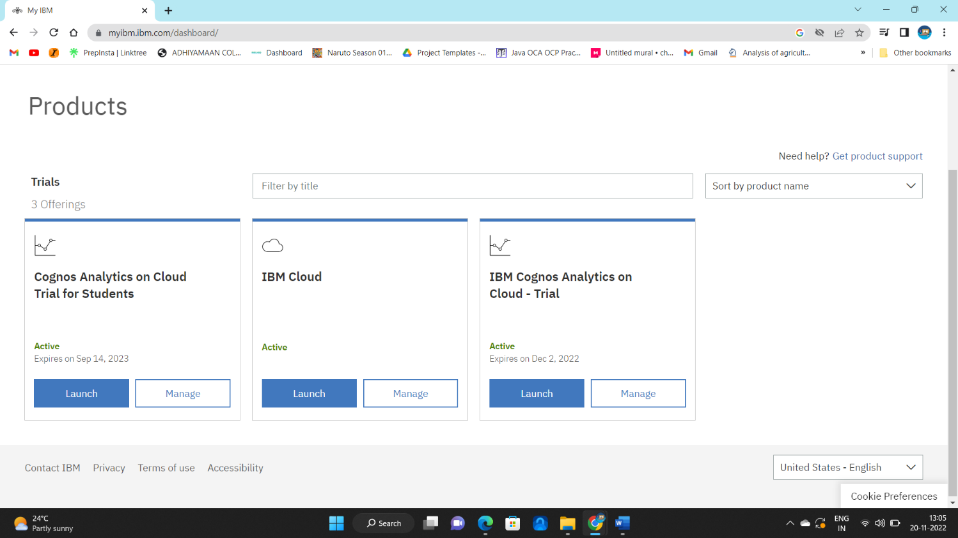

Required accounts successfully set-up.